INVERTING AND NON INVERTING AMPLIFIER

1. Inverting Amplifier

Aim:-
To design an inverting amplifier using an op-amp for the given gain of −2.

Apparatus Required:-
S.No | Components | Specification
1 | Operational Amplifier | IC 741
2 | Resistors | 1 kΩ, 2 kΩ
3 | Breadboard/Trainer Kit | 1
4 | CRO (Cathode Ray Oscilloscope) | 1
5 | Function Generator | 1
6 | Connecting Wires | As required
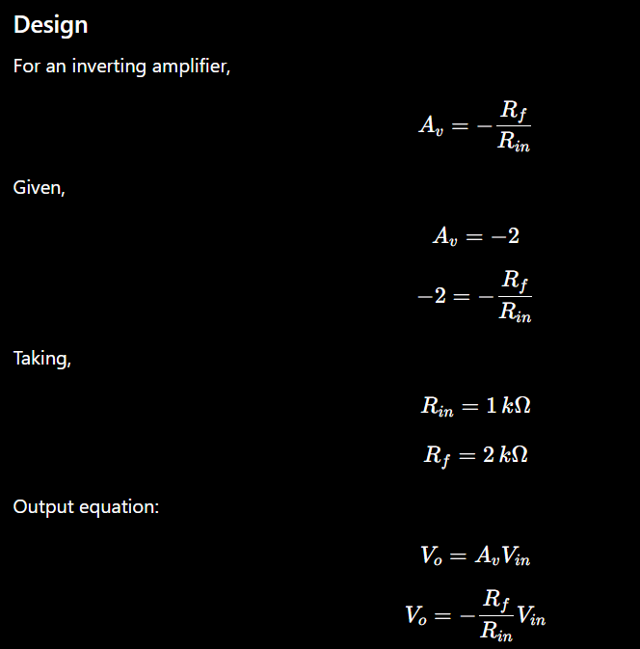

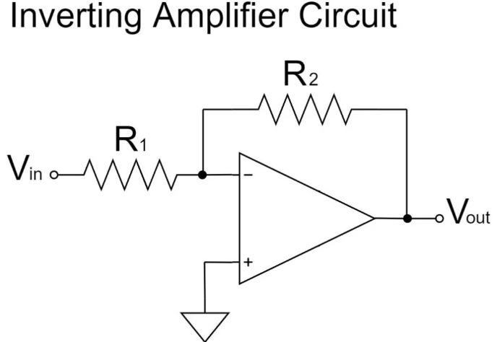

Procedure
- Connect IC 741 on the trainer kit.
- Give dual power supply (+Vcc and −Vcc) to the IC.
- Make the circuit connections as per the circuit diagram.
- Apply sinusoidal input signal from the function generator to the inverting terminal.
- Ground the non-inverting terminal.
- Connect feedback resistor (R_f) between output and inverting terminal.
- Switch ON the power supply and CRO.
- Observe input and output waveforms on the CRO.
- Verify that the output waveform is amplified and 180° out of phase with the input.
- Tabulate the readings.

Observation Table:
S.No | Vin (V) | Vout (V) | Practical Gain | Theoretical Gain
1 | 1V | 2V | 2 | 2
2 | 2V | 4V | 2 | 2
3 | 3V | 6V | 2 | 2

S.No | Vin (V) | Vout (V) | Time Period | Frequency
1 | 0.2V | -2V | 1 ms | 1KHz
2 | 0.4V | -4V | 1 ms | 1KHz
3 | 0.6V | -6V | 1 ms | 1KH

Result
The working of the inverting amplifier was studied and verified successfully.

2. Non-Inverting Amplifier

Aim
To design a non-inverting amplifier using an op-amp for the given gain of 2.

Apparatus Required
S.No | Components | Specification
1 | Operational Amplifier | IC 741
2 | Resistors | 1 kΩ, 2 kΩ
3 | Function Generator | 1
4 | CRO | 1
5 | Dual Power Supply | ±12 V
6 | Trainer Kit | 1
7 | Connecting Wires | As required
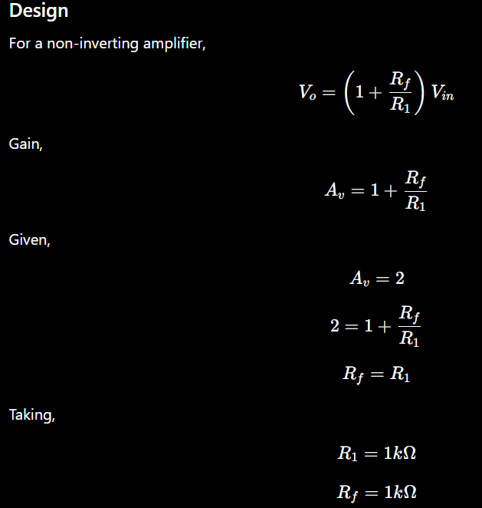

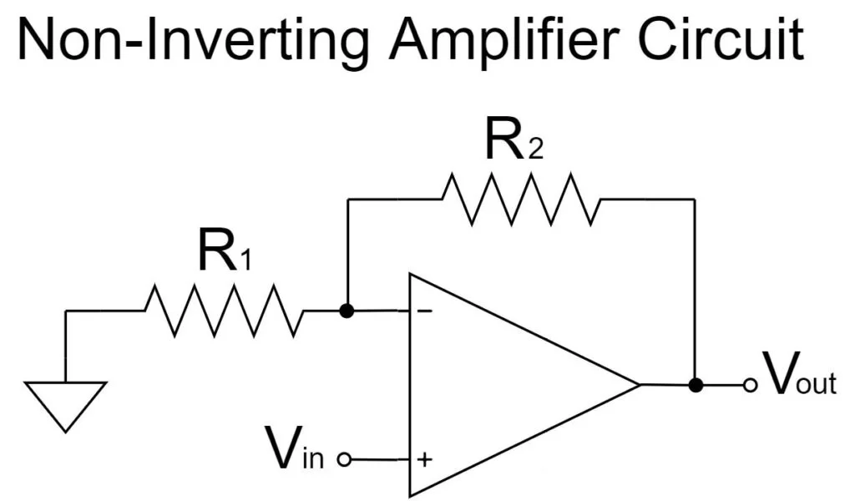

Procedure
- Place IC 741 on the trainer kit.
- Connect dual power supply ±12 V to the IC.
- Make connections as per the circuit diagram.
- Apply sinusoidal input signal from the function generator to the non-inverting terminal.
- Connect feedback resistor (R_f) and resistor (R_1) properly.
- Switch ON the power supply and CRO.
- Observe input and output waveforms on the CRO.
- Measure input voltage, output voltage, time period and frequency.
- Verify that the output waveform is amplified and in phase with the input waveform.
- Tabulate the readings.

Observation Table:
S.No | Vin (V) | Vout (V) | Practical Gain | Theoretical Gain
1 | 1V | 2V | 2 | 2
2 | 2V | 3V | 2 | 2
3 | 3V | 5V | 2 | 2

S.No | Vin (V) | Vout (V) | Time Period | Frequency
1 | 0.2V | 2V | 1 ms | 1KHz
2 | 0.4V | 4V | 1 ms | 1KHz
3 | 0.6V | 6V | 1 ms | 1KHz

Result
The non-inverting amplifier was designed and verified successfully.

